**JMS & Universal Messaging in webMethods**

## ✅ 1. What Is JMS (Java Messaging Service)?

* **JMS** is a **Java API specification** used for asynchronous communication between distributed components.
* It provides a **standard interface** for:
  + Sending (producing) messages
  + Receiving (consuming) messages
* JMS **only defines** how messaging should happen, but doesn’t provide the actual implementation.
* JMS API is a Java interface specification that defines how to connect, send, and receive messages between systems.  
  But it does not implement the actual message logic.  
  The real work — like storing, routing, and delivering messages — is done by JMS providers such as Universal Messaging (UM) in webMethods.

🧠 **Remember:**

JMS = Interface only  
Tools like Universal Messaging = Implementation of JMS

## ✅ 2. What Is a JMS Provider?

A JMS provider is the actual **tool or middleware** that implements the JMS specification and handles messaging.

**🔹 Examples of JMS Providers:**

* IBM WebSphere MQ
* Oracle AQ
* Apache ActiveMQ
* JBoss Messaging
* **webMethods Universal Messaging (UM)**

✅ In webMethods, **Universal Messaging (UM)** is the default and recommended JMS provider.

## ✅ 3. Messaging Models in JMS

JMS supports **two messaging models**:

**🔷 A. Point-to-Point (Queue Model)**

* Uses a **Queue**.
* Only **one receiver** gets each message.
* Multiple senders can send messages to the same queue.
* Each message is consumed **only once** by a single consumer.

📦 **Real-world Use Case:**

* One order-processing service picks up customer orders from a queue and processes them.

**🔷 B. Publish-Subscribe (Topic Model)**

* Uses a **Topic**.
* A **publisher** sends a message to a topic.
* **Multiple subscribers** receive a **copy** of that message.
* Loosely coupled, ideal for broadcasting.

📦 **Real-world Use Case:**

* One pricing update goes to all downstream systems (e.g., CRM, Billing, Reporting).

## ✅ 4. Why Messaging Broker (UM) is Needed?

Imagine a sender client pushing large XML/JSON data. There are multiple receivers, each with different filtering needs. This leads to:

* Complex logic in sender
* Tight coupling
* Difficulty in retrying on failure
* Sender knowing too much about receivers

🔁 **Solution:** Use a **Broker** (like UM) to:

* **Receive** messages
* **Filter** and **route** them
* **Publish** to appropriate receivers (topics/queues)

## ✅ 5. webMethods Messaging Tools Overview

| **Tool** | **Description** |
| --- | --- |
| **webMethods Broker** (legacy) | Older tool used for JMS |
| **Universal Messaging (UM)** | Current and recommended messaging server |
| **Integration Server (IS)** | Publishes/subscribes to messages via UM |

✅ UM is **fully JMS-compliant** and supports all modern messaging features.

## ✅ 6. How Messaging Works in webMethods (JMS + UM)

1. **IS publishes message** using JMS API
2. **UM (JMS Provider)** stores and routes the message
3. **JMS Trigger** in IS subscribes to it and runs a Flow service

**🔁 Components:**

* **JMS Connection Alias**: Defines connection to UM
* **JMS Destination**: Queue or Topic
* **JMS Trigger**: Listens for messages on a destination and runs a Flow service

## ✅ 7. Key Terms & Concepts

| **Concept** | **Description** |
| --- | --- |
| **Publisher/Producer** | Application that sends the message |
| **Subscriber/Consumer** | Application that receives the message |
| **Queue** | Point-to-point, one consumer per message |
| **Topic** | Publish-subscribe, many consumers |
| **JMS Trigger** | Executes a service when a message arrives |
| **Durable Subscriber** | Can receive messages even if temporarily offline |
| **Realm (UM Realm Server)** | A single UM server instance |
| **Enterprise Manager** | GUI to manage and monitor UM (like IS Admin for UM) |

## ✅ 8. Universal Messaging (UM) – In Detail

* **UM** is a **message-oriented middleware** used by webMethods.
* It ensures **guaranteed delivery**, **filtering**, and **scalability**.
* Replaces the now-deprecated **webMethods Broker**.
* Works without needing a web server or firewall changes.

**🔹 Broker-less vs Broker-based**

* **Broker-less**: Direct message passing, lightweight, commonly used.
* **Broker-based**:
  + Messaging Plane: Handles Qs & Topics (sync + async)
  + Comet Plane: Text-based, used in lightweight scenarios
  + Management Plane: APIs to manage UM objects programmatically

**🔹 UM Is Language Agnostic**

* UM can be integrated using:
  + Java
  + .NET
  + C/C++
  + Python (via sockets)
* Can work with other tools like:
  + Oracle Fusion
  + MuleSoft
  + Dell Boomi
  + TIBCO
  + SAP PI
  + Any tool that supports JMS

## ✅ 9. What Is a Realm in UM?

* A **Realm** is simply a **UM Server instance**
* You can define:
  + Channels
  + Topics
  + Queues
  + Clusters
* Think of it like **Integration Server** but for messaging.

## ✅ 10. UM Enterprise Manager (UI Tool)

* GUI tool to manage UM
* Used for:
  + Creating Queues/Topics
  + Monitoring messages
  + Auditing and logging
  + Managing clusters
* Works over SSL/secure sockets
* Highly recommended for developers and admins
* **Enterprise Manager** is a GUI-based admin tool for **Universal Messaging** in webMethods. It allows you to manage, configure, and monitor UM resources like **queues**, **channels**, **topics**, and **JMS destinations**. It also lets you inspect messages, control traffic, and view audit logs.
* It’s built on the UM Admin API and supports remote access via **SSL or socket connections**. It plays a critical role in ensuring the health of JMS-based messaging in webMethods.

## ✅ 11. Integration with IS – Summary

| **Step** | **Action** |
| --- | --- |
| 1. Install & start UM | From webMethods installer or as a service |
| 2. Create **JMS Connection Alias** in IS | Defines Realm, credentials, etc. |
| 3. Create **JMS Destination** | Queue or Topic in UM |
| 4. Create **JMS Trigger** | Listens to a queue/topic |
| 5. Attach a **Flow service** | Executes on message arrival |

## ✅12. 10 Basic Questions on JMS and Universal Messaging

**❓1. What is JMS in webMethods?**

JMS is a Java messaging standard used in webMethods for asynchronous communication between systems. It allows sending and receiving messages via queues and topics.

**❓2. What is the role of Universal Messaging?**

Universal Messaging is the JMS provider in webMethods. It stores, routes, and delivers messages defined through JMS APIs.

**❓3. What is a JMS Connection Alias?**

It's a predefined connection in webMethods that holds configuration to connect to the JMS provider (like UM). It’s used by Flow services and triggers to send/receive messages.

**❓4. What is the difference between Queue and Topic in JMS?**

* **Queue** = Point-to-point → one sender, one receiver
* **Topic** = Publish-subscribe → one sender, many receivers

**❓5. What is a JMS Trigger?**

A JMS trigger listens to a queue or topic and invokes a Flow service when a message arrives.

**❓6. Is JMS synchronous or asynchronous?**

JMS is mostly used for **asynchronous messaging**, but it can also support synchronous request-reply patterns.

**❓7. What is durable subscription in JMS?**

It ensures a subscriber receives all messages even when it is offline, as long as it reconnects later.

**❓8. What is the advantage of using JMS in webMethods?**

Reliable, decoupled, and asynchronous communication — it improves scalability and fault tolerance between systems.

**❓9. What happens if JMS trigger service fails?**

The message is rolled back and retried based on the retry logic configured in the trigger. It can also go to a Dead Letter Queue.

**❓10. How do you monitor JMS messages in webMethods?**

Using MWS or Enterprise Manager (UM UI) — to check queues, topics, subscribers, and message backlogs.

Let me know if you want me to quiz you now or move on to **more tricky JMS questions** — like message selectors, acknowledgement modes, etc. You're on 🔥 Sankar!

## Final Interview-Ready Summary

In my webMethods projects, I used **JMS and Universal Messaging (UM)** for asynchronous messaging.  
JMS is just an API, while UM is the actual broker/server.  
I configured JMS Connection Aliases, created Triggers for queues and topics, and monitored everything via the UM Enterprise Manager.  
This helped us scale integrations, decouple services, and process events reliably without worrying about downtime or tight coupling.

# ✅ Universal Messaging Setup in webMethods

Includes:

* Starting UM
* Enterprise Manager
* IS → UM Configuration
* Key settings and checks

## 🔷 1. What is Universal Messaging (UM)?

**Universal Messaging** is webMethods' messaging backbone that supports:

* **JMS** (Java Messaging Service)
* **Publish–Subscribe** & **Point-to-Point**
* Reliable, asynchronous communication

UM acts as a **JMS provider** in webMethods and replaces the older **Broker**.

## 🔷 2. How to Start Universal Messaging

After installing UM:

**✅ Steps:**

1. Navigate to:  
   SoftwareAG/UniversalMessaging/server/<instanceName>/bin
2. Start the server:
   * On Windows: Double-click nserver.bat
   * On Linux: Run ./nserver.sh
3. If successful:
   * You’ll see **UM started** in the console
   * Default host: localhost
   * Default port: 9000
   * Default protocol: nhp (Universal Messaging native HTTP)

**📘 Result:**

UM is now running and ready to accept messaging connections.

## 🔷 3. What is Enterprise Manager?

Enterprise Manager is a **GUI tool to manage Universal Messaging (UM)**.

It lets you:

* View active **realms (UM servers)**
* Create/manage **channels**, **queues**, **topics**, and **JNDI objects**
* Monitor messages, traffic, and performance
* Configure clustering and access control
* Browse or purge messages in real-time

**✅ To open:**

1. Navigate to:  
   UniversalMessaging/java/umserver/bin/EnterpriseManager.bat
2. Run it → GUI will launch

**✅ Connect to your UM Realm:**

* Realm URL: nhp://localhost:9000
* Click ➕ to add realm, provide this URL, then connect

You’re now able to **administer your UM server**.

## 🔷 4. Configure UM in Integration Server (IS)

To let IS publish/subscribe via UM:

**✅ Steps in IS Admin:**

1. Go to: Settings → Messaging
2. Under **WebMethods Messaging Settings**, click **Edit** for default (or create new)
3. Set the following:

| **Field** | **Description** |
| --- | --- |
| **Connection Name** | Friendly name (e.g., UM_Default) |
| **Client Prefix** | Unique ID (e.g., IS01, Client1) |
| **Realm URL** | e.g., nsp://localhost:9000 or nhp://localhost:9000 |
| **Reconnect Attempts** | Optional — default is fine |

1. Click **Save**
2. Click **Enable**

✅ If everything is correct, it shows a **green checkmark**.  
⚠️ If it's **orange**, you might need to **restart IS** to reflect changes.

## 🔷 5. Why Is This Configuration Important?

This step connects IS to UM so that you can:

* Use **JMS triggers**
* Publish/subscribe using **Flow services**
* Enable **decoupled** and **asynchronous** architectures

## 🔷 6. Real-World Use Case

You have a recharge request system.

* When a customer recharges their mobile, IS **publishes a message** to UM (e.g., rechargeQueue).
* A billing system **subscribes to the queue** and updates account balance.
* Another service may log this transaction asynchronously.

This is fast, reliable, and does **not depend on real-time API responses**.

## 🔷 7. Final Summary

Universal Messaging (UM) is webMethods’ JMS provider used for reliable asynchronous messaging.  
I start UM using the nserver script and manage it using **Enterprise Manager**, which allows me to monitor, configure, and administer channels and queues.  
Once UM is running, I go to **IS Admin → Messaging**, configure the realm using nsp://localhost:9000, assign a unique client prefix, and enable it.  
If the connection is successful, it shows a green tick — else I restart IS.  
After this, I can use **JMS triggers** and publish-subscribe models in Designer for real-time messaging flows.

## comparison between nhp and nsp:

**🔹 nsp (Nirvana Socket Protocol)**

* **Type**: Raw TCP socket protocol
* **Performance**: ✅ Faster
* **Used For**: Internal high-speed communication
* **Firewall**: ❌ Often blocked
* **Port**: Custom (e.g., 9000)

**🔹 nhp (Nirvana HTTP Protocol)**

* **Type**: HTTP-like protocol (messaging over HTTP)
* **Performance**: ⚠ Slightly slower than nsp
* **Used For**: Firewall-safe environments, DMZ, cloud
* **Firewall**: ✅ More accepted (HTTP behavior)
* **Port**: Custom (e.g., 9000 — doesn't have to be 80)

**🎯 Simple Statement:**

**nsp** is faster but can be blocked by firewalls.  
**nhp** is HTTP-style and more firewall-friendly, even on custom ports like 9000.

Let me know if you want to include this in your interview notes! ✅

Great, Sankar! Here's your complete **interview-ready explanation and notes** based on the transcript and enhanced with practical, technical, and real-world clarity.

## ✅ Universal Messaging with JMS Setup in Integration Server

**🔷 Objective**

To enable Integration Server (IS) to **publish and subscribe messages** using **JMS (Java Messaging Service)** through **Universal Messaging (UM)** — which acts as the **JMS provider**.

**🔹 High-Level Steps**

1. Start Universal Messaging (UM)
2. Configure **Enterprise Manager**
3. Create **JNDI Connection Factory** in UM
4. Configure **JNDI Settings** in IS Admin
5. Create and enable **JMS Connection Alias** in IS
6. Use JMS Trigger and Publish in Designer

**🔷 Step-by-Step Breakdown**

### 1. Start Universal Messaging

* Navigate to:  
  SoftwareAG/UniversalMessaging/server/<instanceName>/bin
* Run: nserver.bat (Windows) or nserver.sh (Linux)
* Default protocol: nhp://localhost:9000

### 2. Open Enterprise Manager

* Navigate to:  
  UniversalMessaging/java/umserver/bin/EnterpriseManager.bat
* Add realm using:  
  nhp://localhost:9000 or nsp://localhost:9000
* Connect to the UM server

### 3. Create Connection Factory in UM

This is required for IS to “look up” how to connect to UM via JMS.

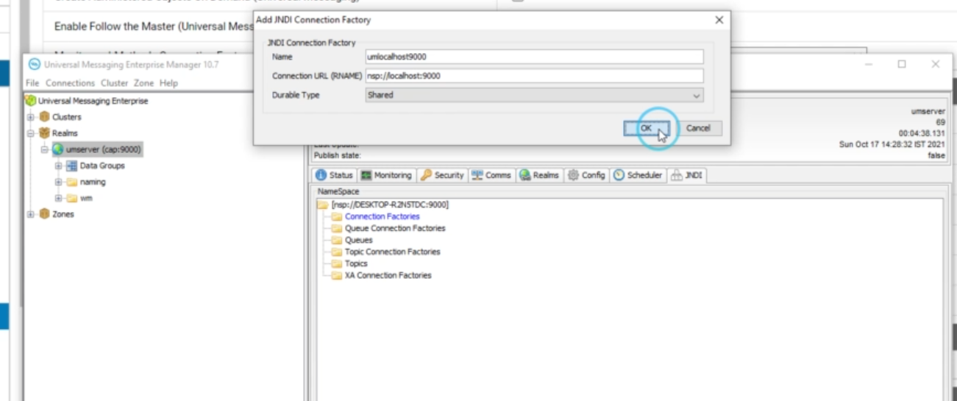

In Enterprise Manager:

1. Go to → **JNDI** → right-click → **New Connection Factory**
2. Name: e.g., localJMSCF
3. Leave defaults unless needed otherwise
4. Save

This factory tells IS how to create JMS sessions when triggered.

### Configure JNDI Settings in IS Admin

IS must know where to find the JNDI Connection Factory.

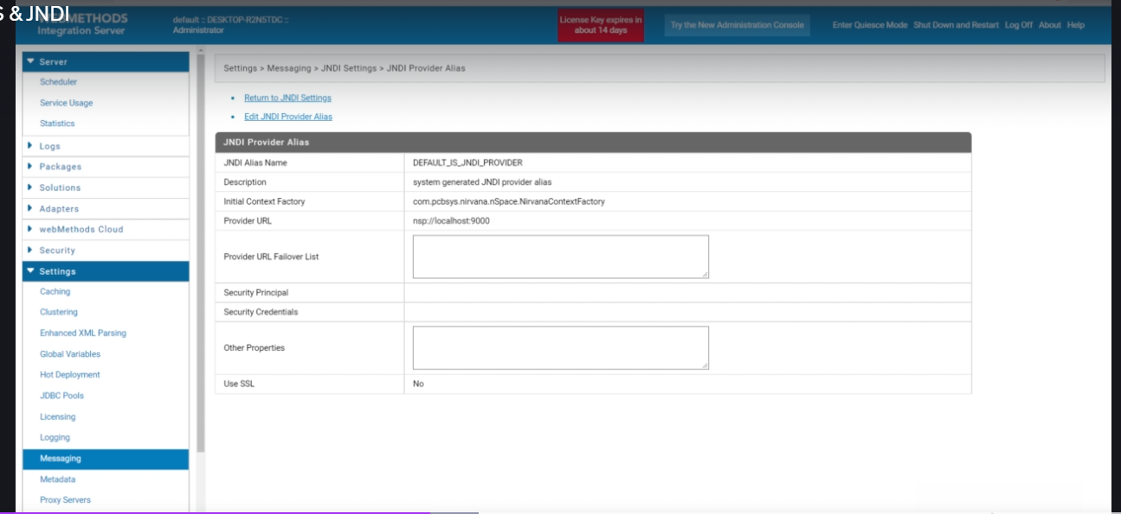

In IS Admin:

* Navigate to: Settings → Messaging → JNDI Settings
* Click **Edit/Create**
* Provide:
  + **Alias Name**: e.g., defaultJNDIProvider
  + **Provider URL**: nsp://localhost:9000 or nhp://localhost:9000
* Save and verify **Green Tick ✅** means it's connected

### 5. Configure JMS Connection Alias

This is the actual **connection bridge** between IS and UM.

In IS Admin:

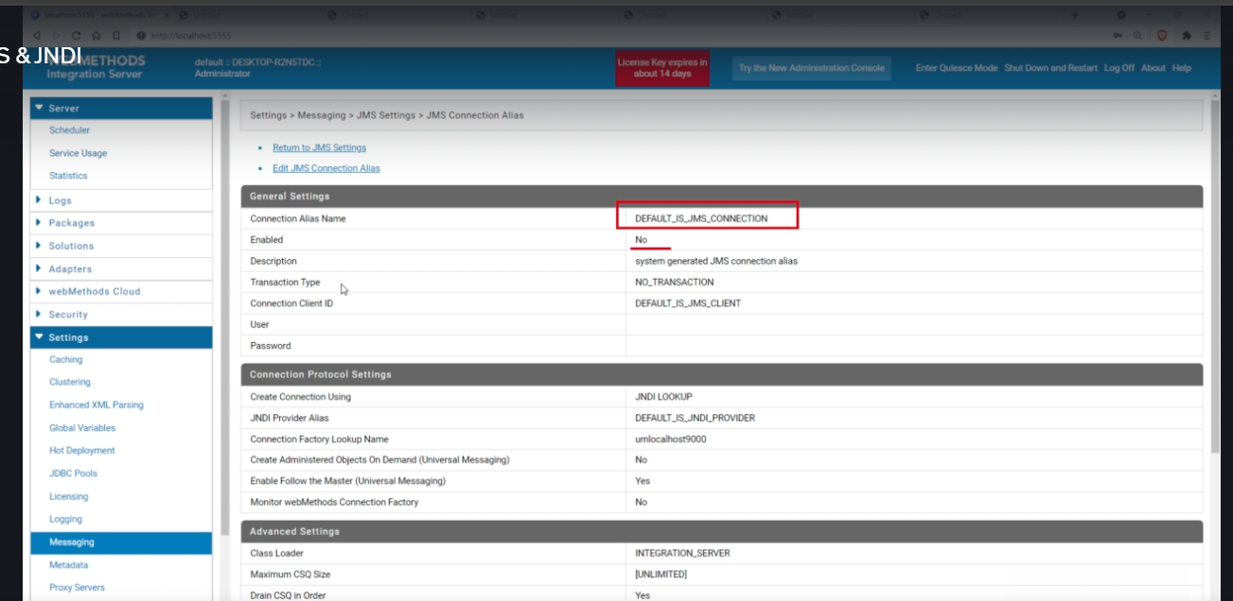

* Navigate to: Settings → Messaging → JMS Settings
* Click **Edit** on default (or create a new one)
* Fill in:

| **Field** | **Value/Example** |
| --- | --- |
| Alias Name | JMS_Local |
| Transaction Type | NO_TRANSACTION (or LOCAL/XA) |
| JNDI Alias | defaultJNDIProvider |
| Connection Factory | localJMSCF |
| Create Objects | ✅ Yes (on demand) |
| ClassLoader | Default |

* Save and click **Enable**

Green check = working ✅  
Orange/yellow = IS restart may be needed ⚠

**🔷 Key Concepts**

**🔹 JMS API**

* A **Java interface/specification** that defines how to send and receive messages between systems.

**🔹 JMS Provider**

* A tool that **implements the JMS API** — e.g., Universal Messaging, IBM MQ, ActiveMQ.

**🔹 JNDI (Java Naming and Directory Interface)**

* API used to **look up JMS resources** like connection factories and destinations (queues/topics).

**🔹 Connection Factory**

* Defines **how to create JMS connections**.
* Created in **UM**, referenced in IS via **JNDI lookup**.

### 🎯 Final Interview Answer

To configure IS for JMS messaging with Universal Messaging, I:

1. Start UM and access Enterprise Manager
2. Create a **Connection Factory** under JNDI
3. Configure JNDI settings in IS (point to UM realm)
4. Create and enable a **JMS Connection Alias** using the JNDI alias and factory

After setup, I can **publish JMS messages using Flow services** and use **JMS triggers** to subscribe.  
This setup helps in real-time, event-driven messaging between systems.

# ✅What is a Publishable Document in webMethods?

A **Publishable Document** is a **special type of document (IData)** in webMethods that is marked as "publishable" so it can be **sent asynchronously via Universal Messaging (UM)** or the older Broker (now deprecated).

Once marked publishable, it becomes eligible for **Publish-Subscribe (Pub-Sub)** messaging, where:

* A **publisher service** sends the document (event/message),
* One or more **subscribers (triggered services)** receive and process it asynchronously.

## 🔁 Purpose of a Publishable Document

The purpose is to **enable asynchronous, loosely coupled communication** between services, especially within the same Integration Server or across clustered IS nodes.

Instead of calling another service directly (synchronous), the publisher simply **publishes the document**, and webMethods takes care of delivering it to **subscribers listening to that document**.

This is useful for:

* **Event-driven architecture**
* **Internal decoupling**
* **Scalability**
* **Asynchronous workflows**

# ✅ What is a Durable Subscriber?

A **Durable Subscriber** is a special type of subscriber in the **Publish-Subscribe (pub-sub)** messaging model (especially when using **JMS topics**) that can **receive messages even if it is temporarily offline**.

It ensures **message reliability** by **storing messages on the Universal Messaging (UM) server disk** until the subscriber reconnects and consumes them.

## 🔄 Difference between Durable and Non-Durable Subscribers

| **Feature** | **Durable Subscriber** | **Non-Durable Subscriber** |
| --- | --- | --- |
| Offline Message Retention | ✅ Messages are stored when subscriber is down | ❌ Messages are lost if subscriber is down |
| Persistence | Disk-based (Persistent storage) | Memory-based (Volatile) |
| Use case | Critical data must be received | Real-time, non-critical updates |
| Subscription name required |  |  |

# ✅What is Queue & Topic and its difference?

## ✅ What is a Queue?

* A **Queue** is a **Point-to-Point** messaging model.
* Only **one consumer** receives each message.
* Messages are held in the queue until a receiver consumes it.

📦 **Think of a queue like a line at a ticket counter** — first in, first out (FIFO).

## ✅ What is a Topic?

* A **Topic** is a **Publish-Subscribe** messaging model.
* Messages are sent to **multiple subscribers**.
* All **active subscribers** to a topic get **a copy** of the message.

📢 **Think of a topic like a radio broadcast** — anyone tuned in receives the message.

## 🔄 Difference Between Queue and Topic

| **Feature** | **Queue** | **Topic** |
| --- | --- | --- |
| Model | Point-to-Point | Publish-Subscribe |
| Receivers per message | Only one | Multiple |
| Message Persistence | Yes (until consumed) | Yes (if durable subscriber is used) |
| Subscribers | One consumer per message | All active subscribers |
| Suitable for | Task queues, one-to-one communication | Notifications, broadcast messages |
| Message loss if down | No (stored until consumed) | Yes (unless **Durable Subscriber** used) |
| Example | Payment processing system (one handler) | Stock price updates to multiple apps |

# ✅Overview: Purpose of sendAndWait / waitForReply / reply

These services enable **two-way communication over JMS**. Unlike normal async publish-subscribe (fire and forget), this allows:

* The **sender to wait** for a **response**.
* The **subscriber** to process and **send a reply back**.
* Can work in **synchronous or asynchronous mode**.

**🔸** Basic Flow Architecture

[Flow A (Publisher)] -- sendAndWait --> [Trigger] -- invokes --> [Flow B (Subscriber)] -- reply --> [Flow A]

Or in **async mode**:

[Flow A] -- send --> ... other steps ...

↓

[waitForReply] <--- reply from Flow B

## 🧩 How Each Service Works

| **Service** | **Role** | **Usage** |
| --- | --- | --- |
| pub.jms:sendAndWait | Sends a JMS message and waits for a reply | Used in Flow A (Publisher) |
| pub.jms:reply | Sends a reply back to original publisher | Used in Flow B (Subscriber) |
| pub.jms:waitForReply | Waits for the reply in async model | Used later in Flow A |

## 🏗️ Key Configuration Points

### 1. Use a publishable document

* Define your input/output structure.
* Mark it as publishable.
* Choose JMS provider (UM) and connection alias.

### 2. Trigger Setup

* Use JMS trigger (NOT webMethods messaging trigger).
* Assign:
  + Connection alias
  + Destination type: Topic or Queue
  + Destination name: Example: topic.request
  + Processing service: Flow B (subscriber)

### 3. Flow A (Publisher) - Using sendAndWait

* Map input to **JMSMessage/body**
* Set timeout (e.g. 10000 ms)
* Set isAsync = false (for synchronous response)
* Output will be JMSMessage (reply received)

### 4. Flow B (Subscriber) - Using reply

* Get the incoming JMS message
* Prepare the reply body
* Call pub.jms:reply
  + Input: JMSMessage
  + Output goes back to sender

### 5. Alternative: Async Mode

* In sendAndWait, set isAsync = true
* No immediate reply expected
* Later in Flow A, use pub.jms:waitForReply
  + Must pass JMSMessage/messageID as correlationId
  + Timeout is mandatory
* You can proceed with other logic in between

### 🛠️ Important Parameters

* **timeout**: Max time (ms) the publisher should wait for a reply
* **isAsync**:
  + false = wait immediately after send
  + true = async; continue flow and wait later
* **correlationID**: Needed in waitForReply to track message
  + Should be same as JMSMessage/messageID

## 💡 Example Use Case (Interview-Ready)

In a telecom project, we had to send customer activation request to a downstream system via JMS and wait for a confirmation. We used sendAndWait to publish the message. The downstream service consumed it and responded using reply. If the response was delayed, we used waitForReply to continue our flow asynchronously. We used durable topics to ensure messages were not lost even if the downstream system was temporarily down.

## 🔒 Durable Topic + Delayed Subscriber Scenario

* If the subscriber is **not available**, the message is stored **in the topic/queue** (based on durability).
* Once the subscriber comes back, the trigger picks up the message.
* Durable settings must be enabled in UM and topic configuration.

## ✅ Best Practices

* Always set timeout in sendAndWait and waitForReply
* Use durable topics/queues for critical flows
* Log failures when waitForReply times out
* Always map JMSMessage/messageID to correlationId when using waitForReply
* Keep separate triggers for request and response to avoid confusion

Let me know if you'd like a **visual diagram (sequence or flow)** or **interview Q&A set** based on this topic.  
  
  
Here are your clean and structured notes on the JMS theoretical concepts (excluding service-level details like pub.jms:send, sendAndWait, reply):

# ✅JMS (Java Message Service) – Theoretical Concepts

## 🧱 JMS Programming Model – 6 Core Components

1. **Producer**
   * A client component that creates and sends messages to a JMS destination (Queue or Topic).
2. **Consumer**
   * A client component that receives messages from a destination (Queue or Topic).
   * Can be durable or non-durable depending on requirement.
3. **Messages**
   * Structure:
     + **Header**: Contains metadata (like destination, timestamp, correlation ID).
     + **Properties**: Optional key-value pairs; used for filtering or business metadata.
     + **Body**: Actual content – can be String, XML, JSON, binary, etc.
4. **Administered Objects**
   * Created by admin using UI or scripts.
   * Includes:
     + **Connection Factory**: Object used by client to connect to JMS provider.
     + **Destination**: Defines the target (Queue or Topic) for messages.
5. **Connection**
   * Active link between JMS client and provider.
   * Manages sessions.
   * Supports concurrent usage.
6. **Session**
   * A single-threaded context used to create producers, consumers, messages, destinations.
   * Handles acknowledgment and transaction management.

## 📌 Message Structure

1. **Header**
   * Includes info like JMSDestination, JMSMessageID, JMSCorrelationID, JMSDeliveryMode, JMSExpiration.
2. **Properties (Optional)**
   * Application-specific or standard values for filtering (e.g., using selectors).
   * E.g., orderType=express, region=ME.
3. **Body**
   * Holds actual message content:
     + TextMessage, BytesMessage, MapMessage, ObjectMessage, StreamMessage.

## 🧠 JMS Acknowledgment Types

1. **AUTO_ACKNOWLEDGE** (Most common)
   * Automatically acknowledges message once received.
   * Used in most projects.
2. **CLIENT_ACKNOWLEDGE**
   * Client must explicitly acknowledge the message after processing using message.acknowledge().
3. **DUPS_OK_ACKNOWLEDGE**
   * Lazy acknowledgment; allows duplicates but improves performance.

## 🔄 JMS Destination Types

1. **Queue**
   * Point-to-point model.
   * One sender, one receiver.
2. **Topic**
   * Publish-subscribe model.
   * Multiple subscribers can receive the same message.
3. **Temporary Queue/Topic**
   * Created at runtime.
   * Exists only for the duration of connection.

## 📋 Administered Objects (JNDI Lookup)

* Stored in JNDI (Java Naming and Directory Interface).
* JMS client uses JNDI lookup to fetch:
  + **ConnectionFactory**
  + **Destination (Queue/Topic)**

## 🧪 JMS Selectors

* Used to filter messages at the consumer level based on header/properties.
* Syntax: propertyName = 'value'
  + Example: "region = 'APAC'"

## 🔐 JMS Delivery & Reliability

* **Durable Subscriber**:
  + Retains messages even if subscriber is down.
  + Subscribed messages delivered when client reconnects.
* **Non-Durable Subscriber**:
  + Messages are lost if subscriber is disconnected.
* **Persistent Delivery Mode**:
  + Ensures message survives provider restart.

## ⚙️ Transactions

1. **No Transaction**
   * No commit or rollback required.
2. **Local Transaction**
   * Session manages transaction boundaries (begin, commit, rollback).
   * Greater control but requires careful implementation.
3. **XA Transaction**
   * Distributed transaction across multiple resources.
   * Common in enterprise-level scenarios.